**Global Sales Data Analytics**

|  |  |
| --- | --- |
| Data | 10-11-2022 |
| Team ID | PNT2022TMID45267 |
| Project Name | Global Sales Data Analytics |

Sales vs Profit by Countries

# Sales by Country

The report on Sales by Country helps management to understand regional aspects of sales and revenue.

Answers to these key questions can be drawn easily using this report:

* Where are we selling, what are we selling there and how much?
* Which regions are the most profitable?
* Does our marketing work in these countries?
* Where do we need to improve sales?

For an international business, it is not enough to just view sales trends in general. With this report, you will be able to narrow it down to specific countries. You will further be able to produce a regional report for specific product lines or sales channels with an appropriate setup of product categories.

This regional view is important for management to understand the business as a whole. Thus, order volume and net sales revenue is presented per country for any chosen time period.

Allowing to filter by products and product categories helps to discover what is contributing the most to your business and where. This also allows to measure the result of targeted marketing campaigns and to reinforce those that work, while allowing to discard those that don’t, based on hard facts.

When no filter filters are used, the report provides figures based on all products ordered within the time period considered. As with the other reports, when filters are used, the data is limited to matching products. The “Extend results” options again serve the purpose of including data from products ordered along with the selected products or categories.

The information provided by this report can be further complemented by the following reports, which provide per-product views on orders, revenue and unit sales by product and country

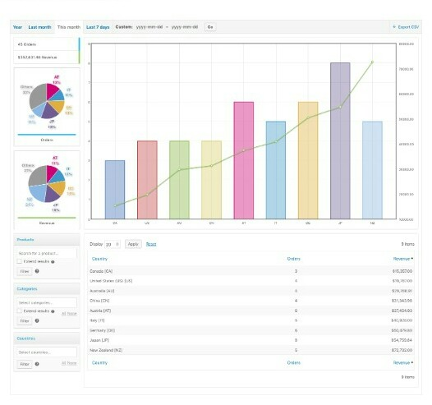

Profits by Country

Tax on corporate profits is defined as taxes levied on the net profits (gross income minus allowable tax reliefs) of enterprises. It also covers taxes levied on the capital gains of enterprises. This indicator relates to government as a whole (all government levels) and is measured in percentage both of GDP and of total taxation.